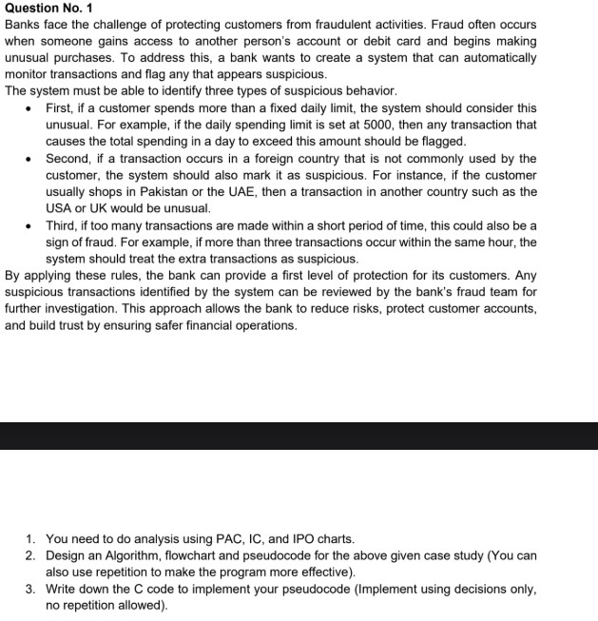

# ➔ Answer

**1.**➔ **PAC**

|  |  |
| --- | --- |
| **Given Data** | **Required Result** |
| 1. **Daily spending limit** ➔ **50000** 2. **Customer’s usual countries** ➔ **Pakistan, UAE** 3. **Max allowed transactions in 1 hour** ➔**3** 4. **Transaction details (amount, country, time)** | **1. Detect and flag suspicious transactions when**➔   1. **Daily spending exceeds 5000.** 2. **Transaction occurs in an unusual country.** 3. **More than 3 transactions happen within 1 hour.** |
| **Processing** | **Alternative Solution** |
| 1. **Input transaction amount, country, and time.** 2. **Check if daily total spending > 5000** ➔ **flag suspicious.** 3. **Check if country != Pakistan/UAE**➔ **flag suspicious.** 4. **Check if number of transactions > 3 in same hour** ➔ **flag suspicious.** 5. **Otherwise, transaction is safe.** | 1. **Use AI models to detect unusual patterns automatically.** 2. **Send alerts to customer via SMS for verification before processing suspicious transactions.** |

# 2.➔ IPO

|  |  |  |
| --- | --- | --- |
| **Input** | **Process** | **Output** |
| * **Transaction amount** * **Total daily spending** * **Country of transaction** * **Number of Transaction per hour** | * **Check if total daily spending > 50000.**  **Check if country != Pakistan Or UA.** * **Check if transactions > 3/hour.** * **Otherwise** | * **Suspicious: Daily limit exceeded** * **Suspicious: Unusual country** * **Suspicious: Too many transactions**   **Transaction is safe** |

# 3.➔ Algorithm

1. **Start**
2. **Input transaction amount, country, total daily spending, and transactions per hour**
3. **If total daily spending > 5000** ➔ **Mark suspicious**
4. **Else if country not equal to Pakistan or UAE** ➔**Mark suspicious**
5. **Else if number of transactions in same hour > 3**➔ **Mark suspicious**
6. **Else transaction is safe**
7. **Display result**
8. **Stop**

# 4.➔Pseudocode

1. Start
2. Input amount, country, total daily spending, transaction per hour.
3. IF total daily spending > 50000 THEN
4. Print "Suspicious transaction: Daily limit exceeded"
5. ELSE IF country != Pakistan AND country != UAE THEN
6. Print "Suspicious transaction: Unusual country"
7. ELSE IF transaction per hour. > 3 THEN
8. Print "Suspicious transaction: Too many transactions in one hour"
9. ELSE
10. Print "Transaction is safe”
11. END IF
12. Stop

# 5.➔ Follow chart

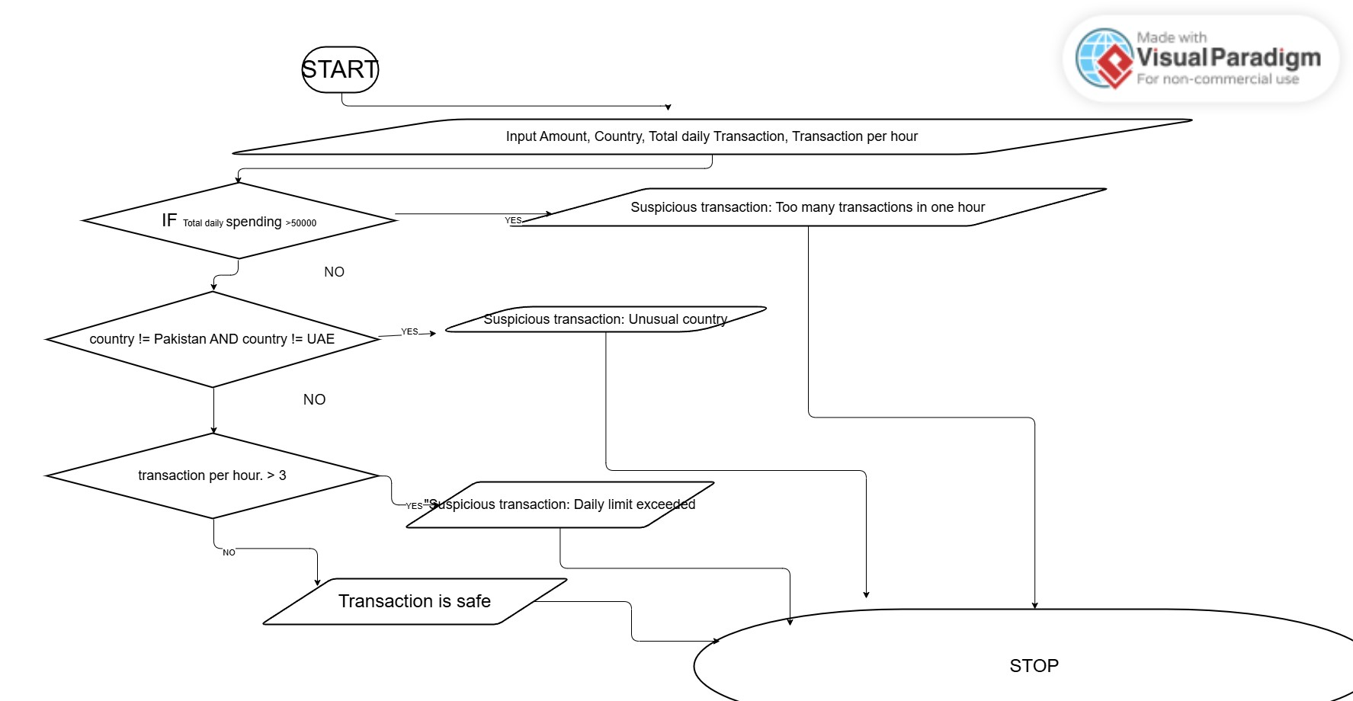

## 6 .➔ C PROGRAM

|  |
| --- |
| #include <stdio.h> |
| #include <string.h> |
|  |
| int main() { |
|  |
| const int DAILY_LIMIT = 50000; |
| const int MAX_TRANSACTIONS_PER_HOUR = 3; |

|  |
| --- |
|  |
|  |
| int total_spending_today; |
| int transaction_amount; |
| char transaction_country[12]; |
| int transactions_in_hour; |
|  |
|  |
| printf("Enter Your today's Spending : "); |
| scanf("%d", &total_spending_today); |
|  |
| printf("Enter the amount of the current transaction: "); |
| scanf("%d", &transaction_amount); |
|  |
| printf("Enter the country of the transaction: "); |
| scanf("%s", transaction_country); |
|  |
| printf("Enter the number of transactions in the last hour: "); |
| scanf("%d", &transactions_in_hour); |
|  |
|  |
| if ((total_spending_today + transaction_amount) > DAILY_LIMIT) { |
| printf("Transaction flagged: Daily spending limit exceeded.\n"); |
| } else if (strcmp(transaction_country, "Pakistan") != 0 && strcmp(transaction_country, "UAE") != 0) { |
| printf("Transaction flagged: Unusual foreign transaction.\n"); |
| } else if (transactions_in_hour > MAX_TRANSACTIONS_PER_HOUR) { |
| printf("Transaction flagged: Too many transactions in a short period.\n"); |
| } else { |
| printf("Transaction is not suspicious.\n"); |
| } |
|  |
| return 0; |
| } |
| **RUNING SS:** |

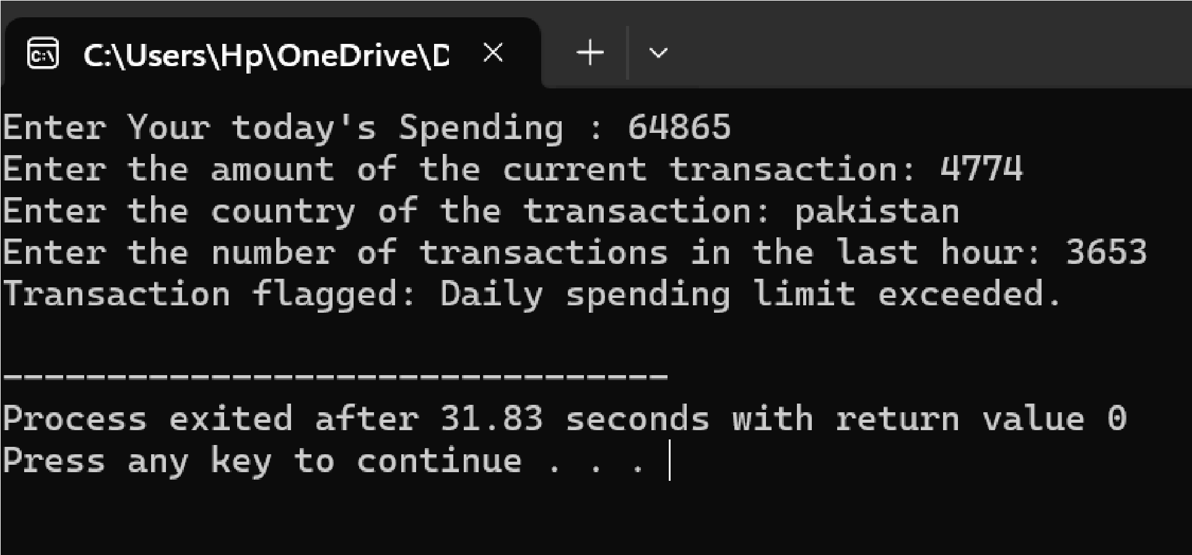

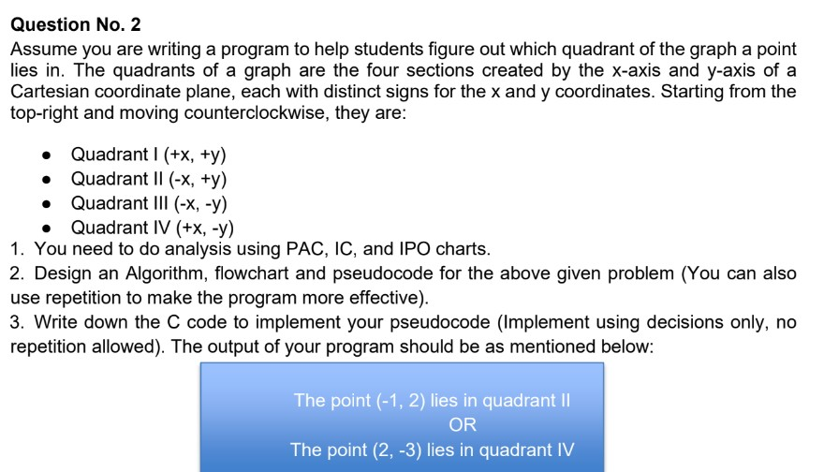

# ➔ Answer

**1.**➔ **PAC**

|  |  |
| --- | --- |
| **Given Data** | **Required Result** |
| 1. **X-Coordinate** 2. **Y-coordinate** | **Display the Correct Position of the given Points in Quadrant System** |
| **Processing** | **Alternative Solution** |
| 1. **Input values of Xand Y** 2. **If (X>0 and Y>0)**➔**Quadrant I.** 3. **Else if (X<0 And Y>0)**➔**Quadrant II.** 4. **Else if (X>0 And Y<0)**➔**Quadrant III.** 5. **Else (X<0 And Y<0)**➔**Quadrant IV.** | 1. **If user enters (0,0) then the Point is at Origin.** 2. **If user enters X=0 , point lies on Xaxis.** 3. **If user enters Y=0,point lies on Yaxis.** |

# 2.➔ IPO

|  |  |  |
| --- | --- | --- |
| **Input** | **Process** | **Output** |
| **X, Y Coordinates** | **Apply Quadrant and Axis Or Origin Conditions** | **Point Location in Quadrants System** |

# 3.➔ Algorithm

1. **START.**
2. **Input X, Y**
3. **If (X>0 and Y>0)**➔ **print** **Quadrant I.**
4. **Else if (X<0 And Y>0)**➔ **print “Quadrant II”.**
5. **Else if (X>0 And Y<0)**➔ **print** **Quadrant III. 6. Else if (X<0 And Y<0)**➔ **print** **Quadrant IV.**
6. **Else if X== 0and Y == 0**➔**print Origin.**
7. **Else if X == 0** ➔**print on X-axis.**
8. **Else if Y == 0** ➔ **print on Y- axis**

1. **End**

# 4.➔Pseudocode

1. **Start** 
   1. **Input X, Y**
   2. **If X>0 and Y>0 then** 
      1. **Print “Quadrant I”**
   3. **Else If X<0 and Y>0 then** 
      1. **Print “Quadrant II”**
   4. **Else If X<0 and Y<0 then** 
      1. **Print “Quadrant III”**
   5. **Else If X>0 and Y<0 then** 
      1. **Print “Quadrant IV”**
   6. **Else If X = 0 and Y = 0 then** 
      1. **Print “Point on Origin”**
   7. **Else If X = 0 then** 
      1. **Print “Point on X-axis” ii) Else If Y = 0 then iii) Print “Point on Y-axis”**
2. **End**

# 5.➔ Follow chart

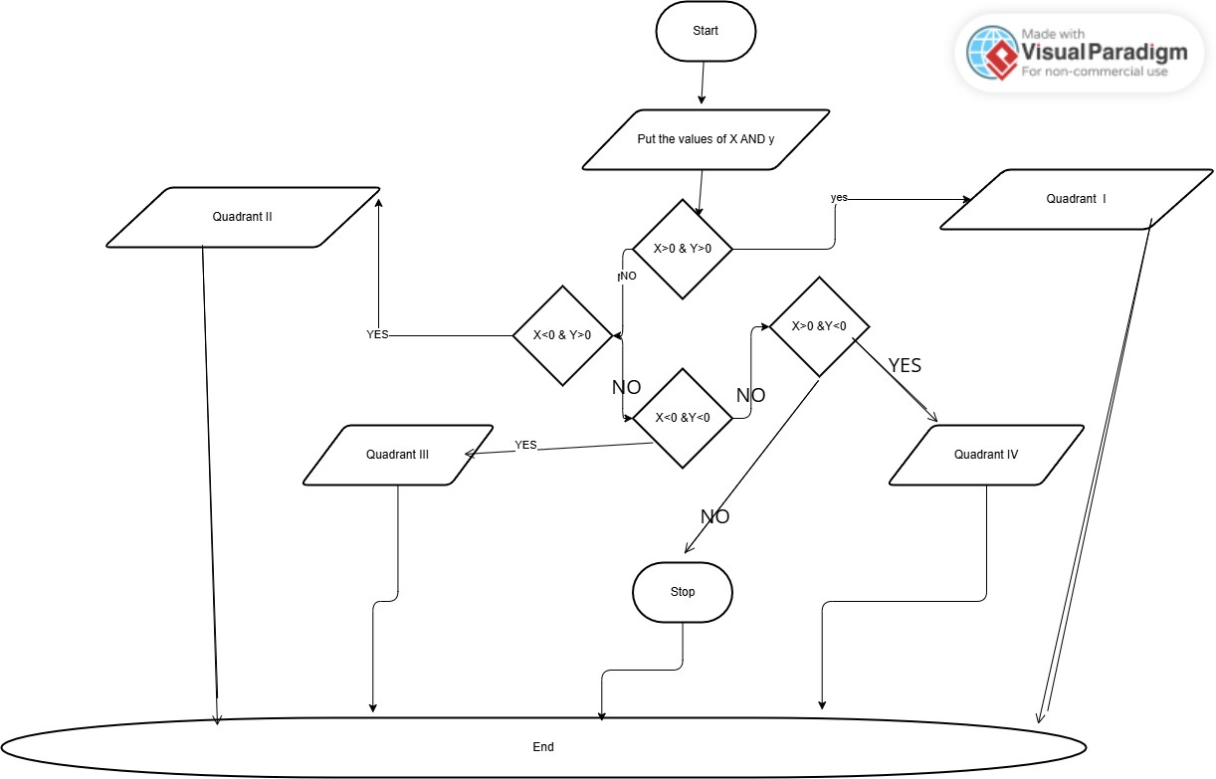

## 6.➔ C PROGRAM

|  |
| --- |
| **#include <stdio.h>** |
|  |
| **int main() {** |
| **int x, y;** |
|  |
| **// Getting Input from user** |
| **printf("Enter the x-coordinate: ");** |
| **scanf("%d", &x);** |
|  |
| **printf("Enter the y-coordinate: ");** |
| **scanf("%d", &y);** |
|  |
|  |
| **if (x > 0 && y > 0)** |
| **{** |
| **printf("The point (%d, %d) lies in quadrant I\n", x, y);** |
| **} else if (x < 0 && y > 0)** |
| **{** |
| **printf("The point (%d, %d) lies in quadrant II\n", x, y);** |
| **} else if (x < 0 && y < 0)** |
| **{** |
| **printf("The point (%d, %d) lies in quadrant III\n", x, y);** |
| **} else if (x > 0 && y < 0)** |
| **{** |
| **printf("The point (%d, %d) lies in quadrant IV\n", x, y);** |
| **} else if (x == 0 && y == 0)** |
| **{** |
| **printf("The point (%d, %d) lies at the origin\n", x, y);** |
| **} else if (x == 0)** |
| **{** |
| **printf("The point (%d, %d) lies on the Y-axis\n", x, y);** |
| **} else** |
| **{** |
| **printf("The point (%d, %d) lies on the X-axis\n", x, y);** |
| **}** |
|  |
| **return 0;** |
| **}** |
| **RUNING SS:** |

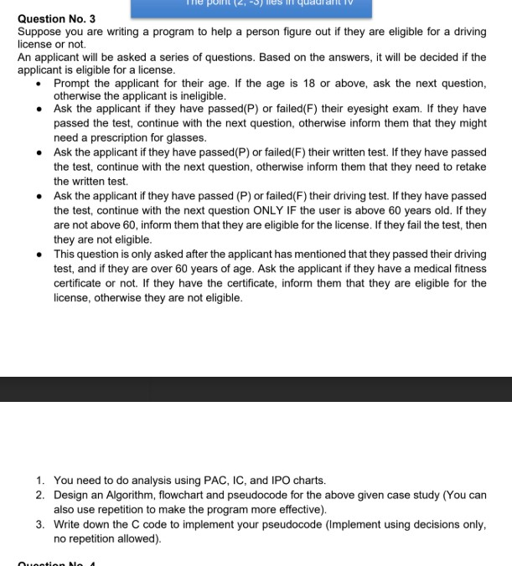

# ➔ Answer

## 1.➔ PAC

|  |  |
| --- | --- |
| **Given Data** | **Required Result** |
| 1. **Applicant’s Age.** 2. **Eyesight test result.** 3. **Written test result.** 4. **Driving test result.** 5. **Medical fitness certificate.** | **Determine eligibility for a driving.** |
| **Processing** | **Alternative Solution** |
| 1. **If Age < 18**➔ **ineligible.** 2. **Eyesight result.**     1. **If failed**➔ **Need proscription glasses.** 3. **Written Result.**     1. **If failed** ➔**Retake Written test.** 4. **Driving Test.**     1. **If failed** ➔ **not eligible. 4.1.1.1. If Passed and Age**   **<=** ➔**Eligible.**  **4.1.1.2. If Passed & Age >**  ➔ **ask**   * + 1. **Medical**   **Certificate.**   * + 1. **If Yes** ➔**Eligible.**     2. **If No** ➔ **not**   **Eligible.** | 1. **If Applicant’s age < 18** ➔ **Directly Rejection.** 2. **Eyesight Failed** ➔ **No process continue further.** 3. **Similarly follow for every step in Application Process.** |

## 2.➔ IPO

|  |  |  |
| --- | --- | --- |
| **INPUT** | **Process** | **Output** |
| **Applicant’s Age,**  **Eyesight, Written test** | **Apply All Sequential Conditions based on** | **Eligible or Not Eligible**  **Message** |
| **result, &Medical Certificate** | **license eligibility rules** |  |

## 3.➔ Algorithm

|  |
| --- |
| 1. *STRAT* 2. *Input Age*     1. *If Age < 18 then print “ineligible for license”* ➔ *end.* 3. *Else Input Eyesight Result.* 4. *If Failed then print “Need prescription”*➔ *end* 5. *Else Written Test Result.*     1. *If Failed then print “Retake Written test again”* ➔ *end.* 6. *Else Ask Driving Test Result.*     1. *If Failed then print “Not Eligible”* ➔*end* 7. *Esle if Pass then*     * 1. *If Age <= 60 then print” Eligible for License”* ➔ *end.*      2. *Else Age >60 then.*          1. *Ask medical certificate.*         2. *If yes then.*             1. *Print” Eligible for License”.*            2. *Else print” Not Eligible “.* |

## 4.➔ Pseudocode

1. *START.*
2. *Input Age*
3. *If age < 18 then*

|  |
| --- |
| *i) print “Ineligible foe license”;*   1. *else* 2. *Input Eyesight*     1. *If Eyesight = fail then*        1. *Print “Need prescription for glasses”;*    2. *Else*        1. *Input Written test Result.*       2. *If Written = fail then*           1. *Print “Retake the Written Test”;*       3. *Else*           1. *Input Driving test Result*              1. *If Driving Test result = Fail then*   *Print “Not Eligible”*   * + - * 1. *Else*   *If Age <= 60 then*  *Print “Eligible for License”*  *Else*  *Input medical Certificate*  *If Medical = yes then*  *Print “Eligible for License”*  *Else* |

*i. Print “Not Eligible”*

## 4.➔FlLOW CHART

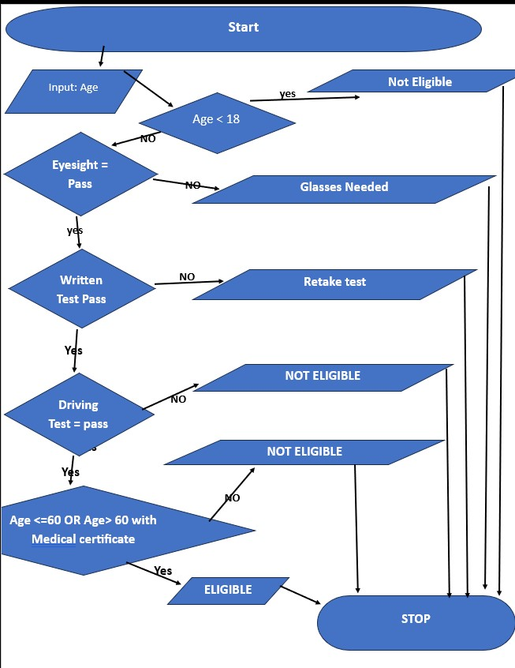

## 5.➔ C PROGRAM

|  |
| --- |
| **#include <stdio.h>** |
|  |
| **int main() {** |
| **int age;** |
| **char eyesight, written_test, driving_test, medical_certificate;** |
|  |
|  |
| **printf("Enter your age: ");** |
| **scanf("%d", &age);** |
|  |
|  |
| **if (age >= 18) {** |
|  |
| **printf("Did you pass your eyesight exam? (P/F): ");** |
| **scanf(" %c", &eyesight);** |
|  |
|  |
| **if (eyesight == 'P' || eyesight == 'p') {** |
|  |
| **printf("Did you pass your written test? (P/F): ");** |
| **scanf(" %c", &written_test);** |
|  |
|  |
| **if (written_test == 'P' || written_test == 'p') {** |
|  |
| **printf("Did you pass your driving test? (P/F): ");** |
| **scanf(" %c", &driving_test);** |
|  |
|  |
| **if (driving_test == 'P' || driving_test == 'p') {** |
|  |
| **if (age > 60) {** |
|  |

|  |
| --- |
| **printf("Do you have a medical fitness certificate? (Y/N): ");** |
| **scanf(" %c", &medical_certificate);** |
|  |
|  |
| **if (medical_certificate == 'Y' || medical_certificate == 'y') {** |
| **printf("Congratulations! You are eligible for a license.\n");** |
| **} else {** |
| **printf("You are not eligible for a license. A medical certificate is required.\n");** |
| **}** |
| **} else {** |
|  |
| **printf("Congratulations! You are eligible for a license.\n");** |
| **}** |
| **} else {** |
|  |
| **printf("You are not eligible for a license. You need to retake the driving test.\n");** |
| **}** |
| **} else {** |
|  |
| **printf("You are not eligible for a license. You need to retake the written test.\n");** |
| **}** |
| **} else {** |
|  |
| **printf("You are not eligible for a license. You might need a prescription for glasses.\n");** |
| **}** |
| **} else {** |
|  |
| **printf("You are not eligible for a license. You must be at least 18 years old.\n");** |
| **}** |
|  |
| **return 0;** |
| **}** |
| **RUNING SS:** |

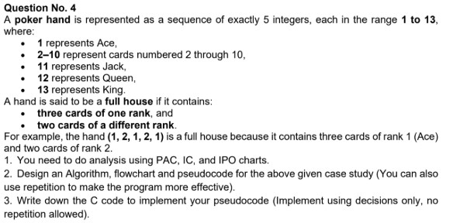

# ➔ Answer

## 1.➔ PAC

|  |  |
| --- | --- |
| **Given Data** | **Required Result** |
| ➢ 5 integers from 1 to 13  Representing the cards. | ➢ Checking whether it is Full House or NOT |
| **Processing** | **Alternative Solution** |
| * Input 5 integers. * Each card has distinct value & count its occurrences. * If one value occurs 3 times & another occurs 2 times ➔FULL HOUSE. * Otherwise ➔NOT FULL HOUSE | * Instead of counting check pattern. ➢ Pattern 1: XXXYY * Pattern 2: XXYYY. |

## 2.➔ IPO

|  |  |  |
| --- | --- | --- |
| **Input** | **Processing** | **Output** |
| ➢ 5 cards | ➢ Count the occurrence of each card OR check patterns | ➢ FULL HOUSE OR NOT FULL HOUSE |

## 3.➔ ALGORITHM

1. *START.*
2. *Input 5 Cards.*
3. *Coun t for each card, how many times it occurs (using loop).*
4. *Keep counting the cards>*
5. *If one card appears 3 times & another 2 times then show that it is FULL HOUSE.*
6. *Otherwise show it is NOT FULL HOUSE.*
7. *End.*

## 4.➔ PSEUDOCODE

|  |
| --- |
| *START.*  *Input cards c1, c2, c3, c4,& c5.*  *For each card.*  *Count how many times it repeats.*  *End for.*  *If (there is count = 3 & a count =2) then Print “it is FULL HOUSE”; Else.*  *Print “it is not FULL HOUSE”; End if* |

## 5.➔ FOLLOW CHART

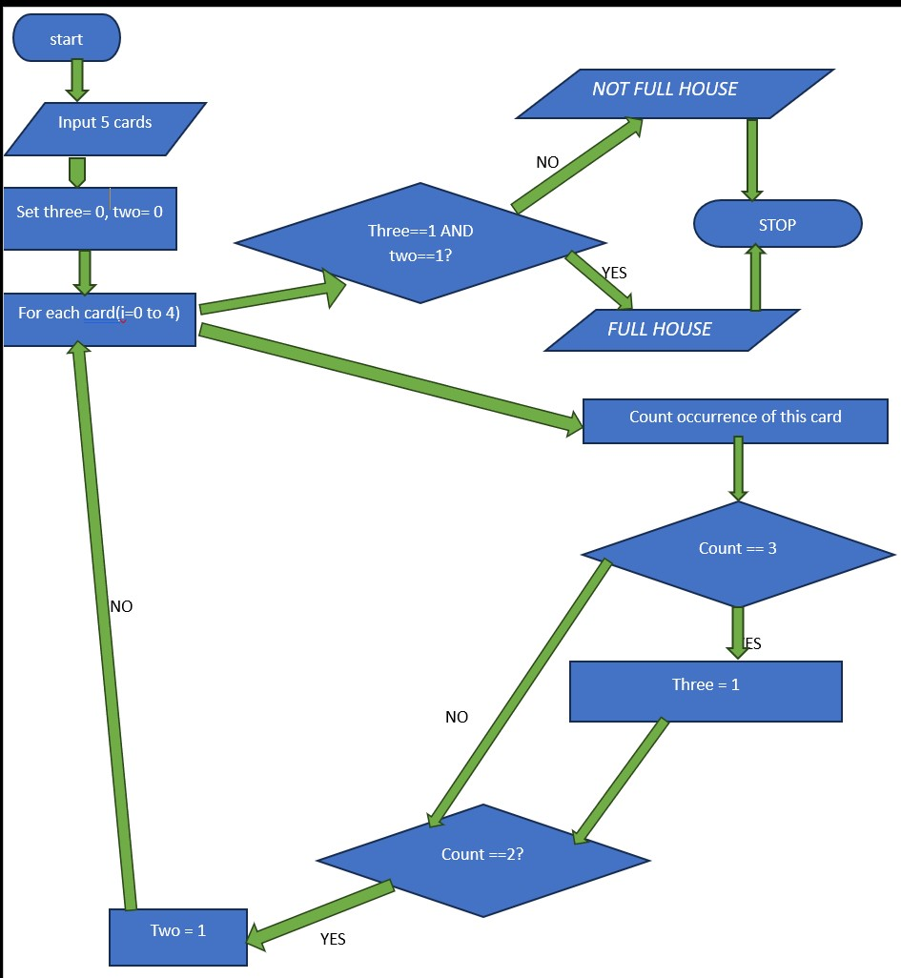

## 5.➔ C PROGRAM

|  |
| --- |
| **#include <stdio.h>** |
|  |
| **int main() {** |
| **int a, b, c, d, e;** |
| **printf("Enter 5 cards (1-13): ");** |
| **scanf("%d %d %d %d %d", &a, &b, &c, &d, &e);** |
|  |
| **int countA=0, countB=0, countC=0, countD=0, countE=0;** |
|  |
| **// count occurrences of a** |
| **if(a==b) countA++;** |
| **if(a==c) countA++;** |
| **if(a==d) countA++;** |
| **if(a==e) countA++;** |
| **countA++;** |
|  |
| **// count occurrences of b** |
| **if(b!=a) {** |
| **countB++;** |
| **if(b==c) countB++;** |
| **if(b==d) countB++;** |
| **if(b==e) countB++;** |
| **}** |
|  |
| **// count occurrences of c** |
| **if(c!=a && c!=b) {** |
| **countC++;** |
| **if(c==d) countC++;** |
| **if(c==e) countC++;** |

|  |
| --- |
| **}** |
|  |
| **// count occurrences of d** |
| **if(d!=a && d!=b && d!=c) {** |
| **countD++;** |
| **if(d==e) countD++;** |
| **}** |
|  |
| **// count occurrences of e** |
| **if(e!=a && e!=b && e!=c && e!=d) {** |
| **countE++;** |
| **}** |
|  |
| **// check full house condition** |
| **if( (countA==3 && (countB==2 || countC==2 || countD==2 || countE==2)) ||** |
| **(countB==3 && (countA==2 || countC==2 || countD==2 || countE==2)) ||** |
| **(countC==3 && (countA==2 || countB==2 || countD==2 || countE==2)) ||** |
| **(countD==3 && (countA==2 || countB==2 || countC==2 || countE==2)) ||** |
| **(countE==3 && (countA==2 || countB==2 || countC==2 || countD==2)) )** |
| **{** |
| **printf("Full House\n");** |
| **} else {** |
| **printf("Not a Full House\n");** |
| **}** |
|  |
| **return 0;** |
| **}** |
| **RUNING SS:** |

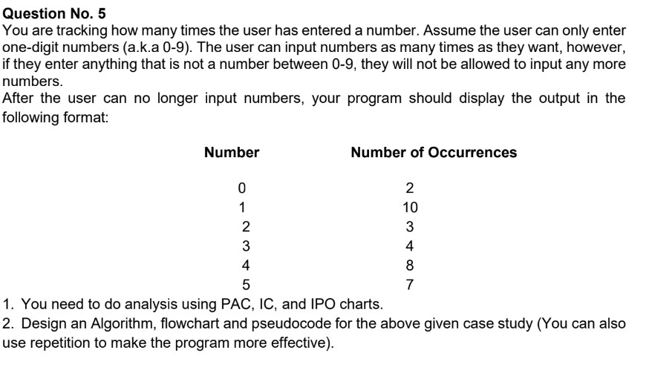

# ➔ Answer

## 1.➔ PAC

|  |  |
| --- | --- |
| **Given Data** | **Required Result** |
| * **Inputs numbers 0 to.** * **Input continues until a non-digit is entered.** | ➢ **Show how many times each digit (0 to 9) was entered.** |
| **Processing** | **Alternative Solution** |
| * **Initialize counters for 0 to 9.** * **Repeat asking input.** * **If input is between 0 to 9 then increment the counter of respective number.** * **If enter digit is not between 0 to 9 then stop.** * **Display all counters.** | ➢ **We can use separate variable for each digit.** |

## 2.➔ IPO

|  |  |  |
| --- | --- | --- |
| **Input** | **Processing** | **Output** |
| ➢ **Inputs 0 to 9 from user until invalid digit entered.** | * **Initi italize Count0 to Count9 =0.** * **Increment the correct count based on input digit.** * **Stop on invalid**   **digit entry.** | ➢ **Make table of occurrence of each number 0 to 9** |

## 3.➔ALGORITHM

|  |
| --- |
| 1. *START.* 2. *Initialize counter:* 3. *Count0 4. Count1* 4. *Count2* 5. *Count3 7. Count4 8. Count5* 6. *Count6* 7. *Count7* 8. *Count8* 9. *Count9.* 10. *Repeat.* 11. *Read input* 12. *If input =0* ➔ *count0+1* 13. *Else if input=1*➔ *Count1 +1* 14. *Else if input= 2 Count2 +1 18. Else if input= 3 Count3 +1 19. Else if input= 4 Count4 +1 20. Else if input= 5 Count5 +1 21. Else if input= 6 Count6 +1 22. Else if input= 7 Count7 +1*   *23. Else if input= 8 Count8 +1 24. Else if input= 9 Count9 +1.*   1. *Else stop loop.* 2. *Print all counters 0 to 9.* 3. *Stop.* |

## 4.➔PSEUDOCODE

* *START*
* *count0, count1, …, count9 = 0*

* *REPEAT*
* *INPUT number*

* *IF number == 0 THEN count0 = count0 + 1*
* *ELSE IF number == 1 THEN count1 = count1 + 1*
* *ELSE IF number== 2 THEN count2 = count2 + 1*
* *ELSE IF number== 3 THEN count3 = count3 + 1*
* *ELSE IF number== 4 THEN count4 = count4 + 1*
* *ELSE IF number == 5 THEN count5 = count5 + 1*
* *ELSE IF number == 6 THEN count6 = count6 + 1*
* *ELSE IF number == 7 THEN count7 = count7 + 1*
* *ELSE IF numbee == 8 THEN count8 = count8 + 1*
* *ELSE IF numbee == 9 THEN count9 = count9 + 1*
* *ELSE*
* *EXIT LOOP*
* *UNTIL invalid input*

* *PRINT Number Occurrence*
* *PRINT "0 ", count0*
* *PRINT "1 ", count1*
* *PRINT "2 ", count2*
* *PRINT "3 ", count3*
* *PRINT "4 ", count4*
* *PRINT "5 ", count5*
* *PRINT "6 ", count6*
* *PRINT "7 ", count7*
* *PRINT "8 ", count8*
* *PRINT "9 ", count9*
* *STOP*

## 5.➔FOLLOW CHART

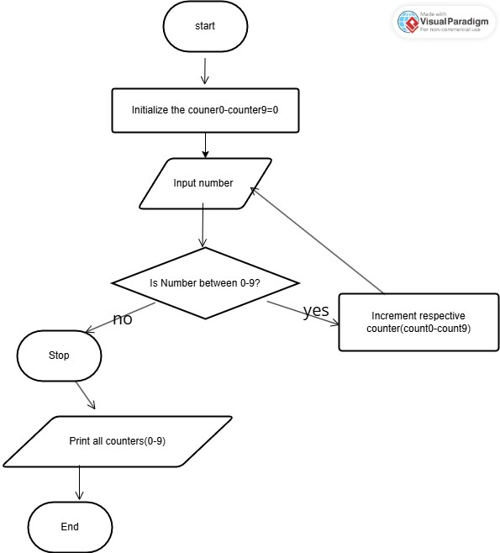

➔**SECTION B**

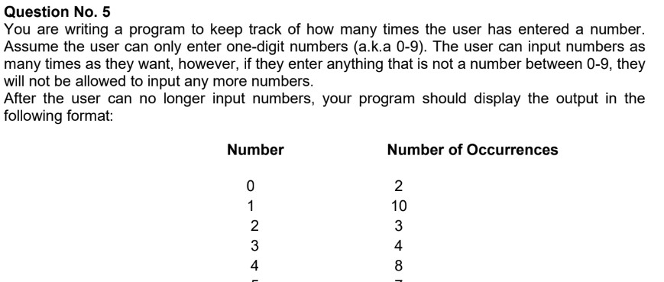

# ➔ Answer

|  |
| --- |
| **#include <stdio.h>** |
|  |
| **int main() {** |
|  |
| **int count0 = 0;** |
| **int count1 = 0;** |
| **int count2 = 0;** |
| **int count3 = 0;** |
| **int count4 = 0;** |
| **int count5 = 0;** |
| **int count6 = 0;** |
| **int count7 = 0;** |
| **int count8 = 0;** |
| **int count9 = 0;** |
|  |
| **int number;** |
| **int scan_result;** |
|  |
| **printf("Enter one-digit numbers (0-9). Enter any other number to stop.\n");** |

|  |
| --- |
|  |
| **while (1) {** |
| **printf("Enter a number: ");** |
| **scan_result = scanf("%d", &number);** |
|  |
|  |
| **if (scan_result == 1 && number >= 0 && number <= 9)** |
| **{** |
|  |
| **if (number == 0)** |
| **{** |
| **count0++;** |
| **}** |
| **else if (number == 1)** |
| **{** |
| **count1++;** |
| **}** |
| **else if (number == 2)** |
| **{** |
| **count2++;** |
| **}** |
| **else if (number == 3)** |
| **{** |
| **count3++;** |
| **}** |
| **else if (number == 4)** |
| **{** |
| **count4++;** |
| **}** |
| **else if (number == 5)** |
| **{** |
| **count5++;** |
| **}** |
| **else if (number == 6)** |
| **{** |
| **count6++;** |
| **}** |
| **else if (number == 7)** |
| **{** |
| **count7++;** |
| **}** |

|  |
| --- |
| **else if (number == 8)** |
| **{** |
| **count8++;** |
| **}** |
| **else if (number == 9)** |
| **{** |
| **count9++;** |
| **}** |
| **}** |
| **else** |
| **{** |
|  |
| **printf("Invalid input. Program terminated.\n\n");** |
| **break;** |
| **}** |
| **}** |
|  |
|  |
| **printf("Number\t\tNumber of Occurrences\n");** |
| **printf("0\t\t%d\n", count0);** |
| **printf("1\t\t%d\n", count1);** |
| **printf("2\t\t%d\n", count2);** |
| **printf("3\t\t%d\n", count3);** |
| **printf("4\t\t%d\n", count4);** |
| **printf("5\t\t%d\n", count5);** |
| **printf("6\t\t%d\n", count6);** |
| **printf("7\t\t%d\n", count7);** |
| **printf("8\t\t%d\n", count8);** |
| **printf("9\t\t%d\n", count9);** |
|  |
| **return 0;** |
| **}** |

**RUNING SS**

**:**

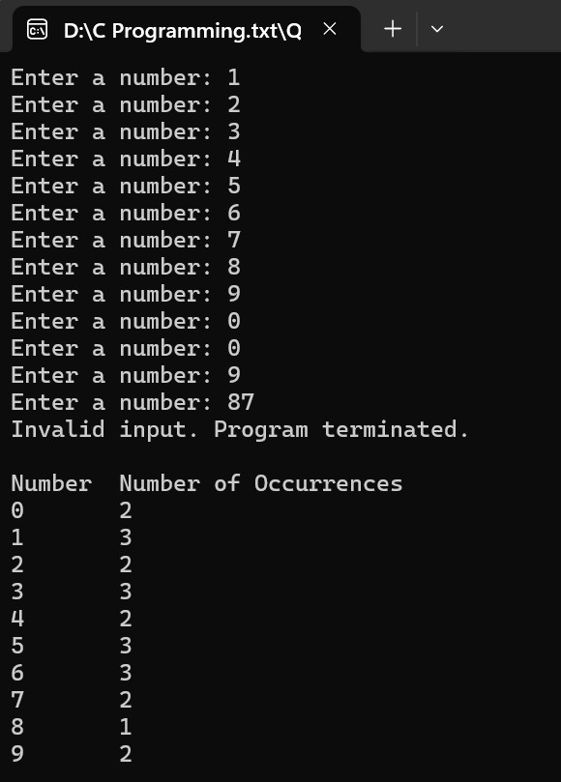

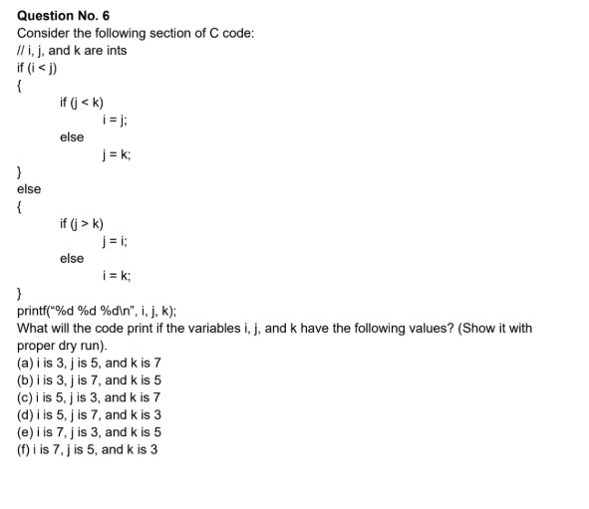

# ➔ Answer

## ➔DRY RUN

|  |  |  |  |  |  |  |  |  |
| --- | --- | --- | --- | --- | --- | --- | --- | --- |
| ***Case*** | ***I***  ***(start)*** | ***J(start)*** | ***K(start)*** | ***I<j*** | ***J<k*** | ***j>k*** | ***Action taken*** | ***Printf(I,j,k)*** |
| ***A*** | ***3*** | ***5*** | ***7*** | ***1*** | ***1*** | ***–*** | ***I=j*** | ***5,5,7*** |
| ***B*** | ***3*** | ***7*** | ***5*** | ***1*** | ***0*** | ***–*** | ***J=k*** | ***3,5,5*** |
| ***C*** | ***5*** | ***3*** | ***7*** | ***0*** | ***–*** | ***0*** | ***I=k*** | ***7,3,7*** |
| ***D*** | ***5*** | ***7*** | ***3*** | ***1*** | ***0*** | ***–*** | ***J=k*** | ***5,3,3*** |
| ***E*** | ***7*** | ***3*** | ***5*** | ***0*** | ***–*** | ***0*** | ***I=k*** | ***5,3,5*** |
| ***F*** | ***7*** | ***5*** | ***3*** | ***0*** | ***–*** | ***1*** | ***J=i*** | ***7,7,3*** |

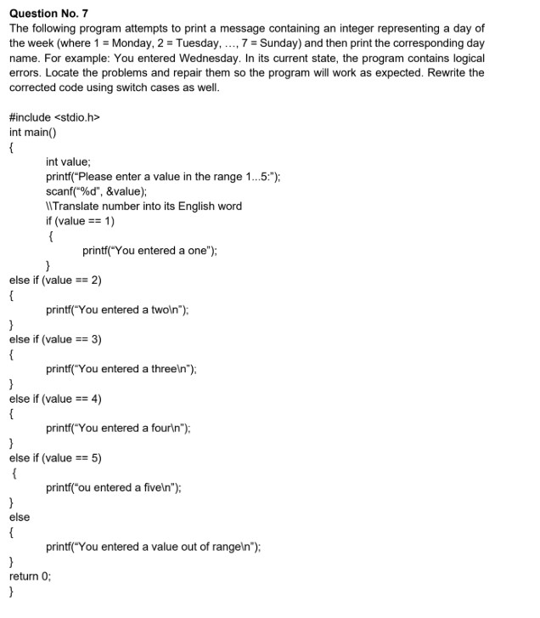

# ➔ Answer

➔**Corrected Version of the given Code:**

|  |
| --- |
| *#include <stdio.h>* |
| *int main()* |
| *{* |
| *int value;* |
| *printf("Please enter a value in the range 1...7: ");* |
| *scanf("%d", &value);* |
|  |
| *// Translate number into day of week* |
| *if (value == 1)* |
| *{* |
| *printf("You entered Monday\n");* |
| *}* |
| *else if (value == 2)* |
| *{* |
| *printf("You entered Tuesday\n");* |
| *}* |
| *else if (value == 3)* |
| *{* |
| *printf("You entered Wednesday\n");* |
| *}* |
| *else if (value == 4)* |
| *{* |
| *printf("You entered Thursday\n");* |
| *}* |
| *else if (value == 5)* |
| *{* |
| *printf("You entered Friday\n");* |
| *}* |
| *else if (value == 6)* |
| *{* |
| *printf("You entered Saturday\n");* |
| *}* |
| *else if (value == 7)* |
| *{* |
| *printf("You entered Sunday\n");* |
| *}* |
| *else* |
| *{* |
| *printf("You entered a value out of range\n");* |
| *}* |
| *return 0;* |
| *}* |

**RUNING SS:**

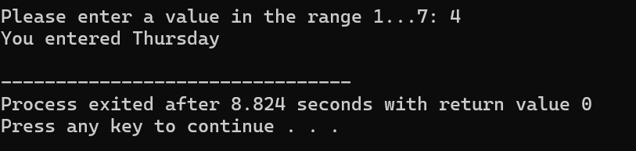

➔**Corrected Version of Switch Case:**

|  |
| --- |
| #include <stdio.h> |
| int main() |
| { |
| int value; |
| printf("Please enter a value between 1 to 7: "); |
| scanf("%d", &value); |
|  |
| switch(value) |
| { |
| case 1: printf(" Monday\n"); break; |
| case 2: printf(" Tuesday\n"); break; |
| case 3: printf(" Wednesday\n"); break; |
| case 4: printf("Thursday\n"); break; |
| case 5: printf("Friday\n"); break; |
| case 6: printf("Saturday\n"); break; |
| case 7: printf("Sunday\n"); break; |
| default: printf("You entered a value out of range\n"); |
| } |
|  |
| return 0; |
| } |

**RUNING SS:**

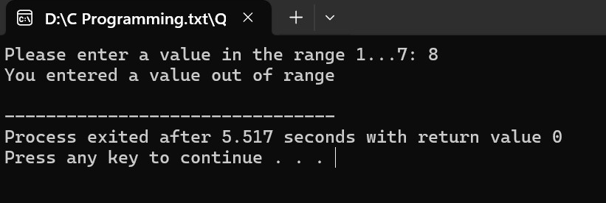

Program Files

Link: <https://github.com/k250845-lab/C-programming-Lab>